LAB 1 - KHÁM PHÁ VÀ LÀM SẠCH DỮ LIỆU
Dataset: Iris Dataset (Kaggle/UCI)

Bài 1: Khám phá dữ liệu ban đầu
from sklearn.datasets import load_iris
import pandas as pd
import matplotlib.pyplot as plt
iris = load_iris(as_frame=True)
df = iris.frame
print(df.head(10))
print(df.shape)
print(df.dtypes)
print(df.describe())
df.hist(figsize=(10,8))
plt.show()
df['target'].value_counts().plot(kind='bar')
plt.show()
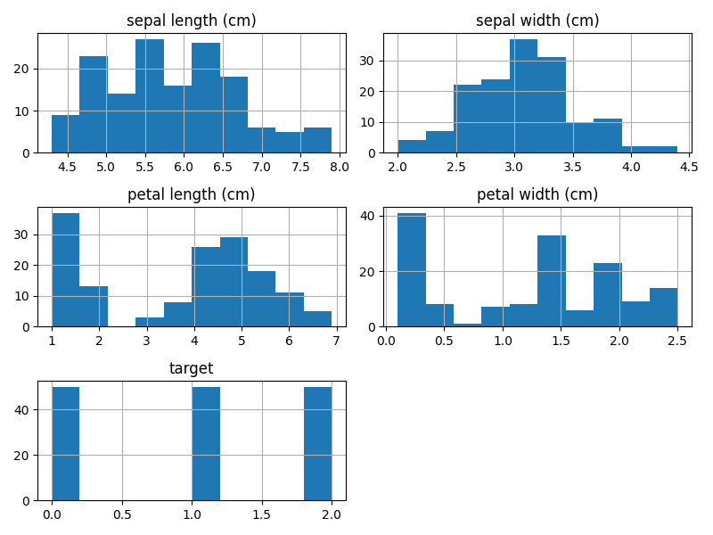
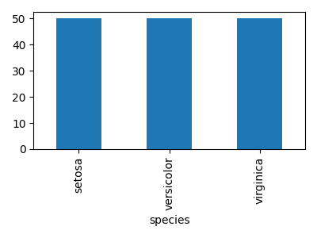

Bài 2: Làm sạch dữ liệu
from sklearn.preprocessing import StandardScaler
import numpy as np
print(df.isnull().sum())
df.iloc[0,0] = np.nan
for col in df.select_dtypes(include='number').columns:
df[col] = df[col].fillna(df[col].mean())
df = df.drop_duplicates()
scaler = StandardScaler()
df[df.select_dtypes(include='number').columns] = scaler.fit_transform(
df.select_dtypes(include='number')
)
df.boxplot()
plt.show()
